**CSE3002**

**Internet and Web Programming Lab**

**L43-L44**

**Faculty – Dr.Prassanna J**

**Lab Assignment – 10**

**Name: Nikhil Neogy**

**Reg. No: 17BCE1083**

**Ex No: 1** **Date: 20.03.19**

Write a PHP program to copy the student details from one text file into another text file. The student details include register number, name, school and marks. Upload the copied file. The uploaded file should be only text file.

Code:

file.php:

<!DOCTYPE html>

<html>

<body>

<form action="" method="POST">

<table>

<tr>

<td> Enter the location of the file to be copied </td> <td> <input type='text' name ='file1'> </td>

</tr>

<tr>

<td> Enter the location of the copied file </td> <td> <input type='text' name = 'file2'> </td>

</tr>

</table>

<input type='submit' name='submit'>

</form>

</body>

</html>

<?php

if(isset($_POST['submit']))

{

$myfile = fopen($_POST['file1'],"r");

$myfile2 = fopen($_POST['file2'],"w+");

$content = fread($myfile,filesize($_POST['file1']));

$var = fclose($myfile);

fwrite($myfile2,$content);

fclose($myfile2);

if($var)

{

echo "File Successfully Copied";

header('refresh:5,location:upload.php');

}

}

?>

upload.php:

<!DOCTYPE html>

<html>

<body>

<form action="" method="post" enctype="multipart/form-data">

Filename:

<input type="file" name="image"><br>

<input type="submit" name="submit" value="Submit"> </form>

</body>

</html>

<?php

if(isset($_FILES['image']))

{

$errors= array();

$file_name = $_FILES['image']['name'];

$file_size =$_FILES['image']['size'];

$file_tmp =$_FILES['image']['tmp_name'];

$file_type=$_FILES['image']['type'];

$slash='/';

if(empty($errors)==true)

{

move_uploaded_file($file_tmp,"upload/".$file_name); echo "Successfully Uploaded";

}

else

{

print_r($errors);

}

}

?>

Output:

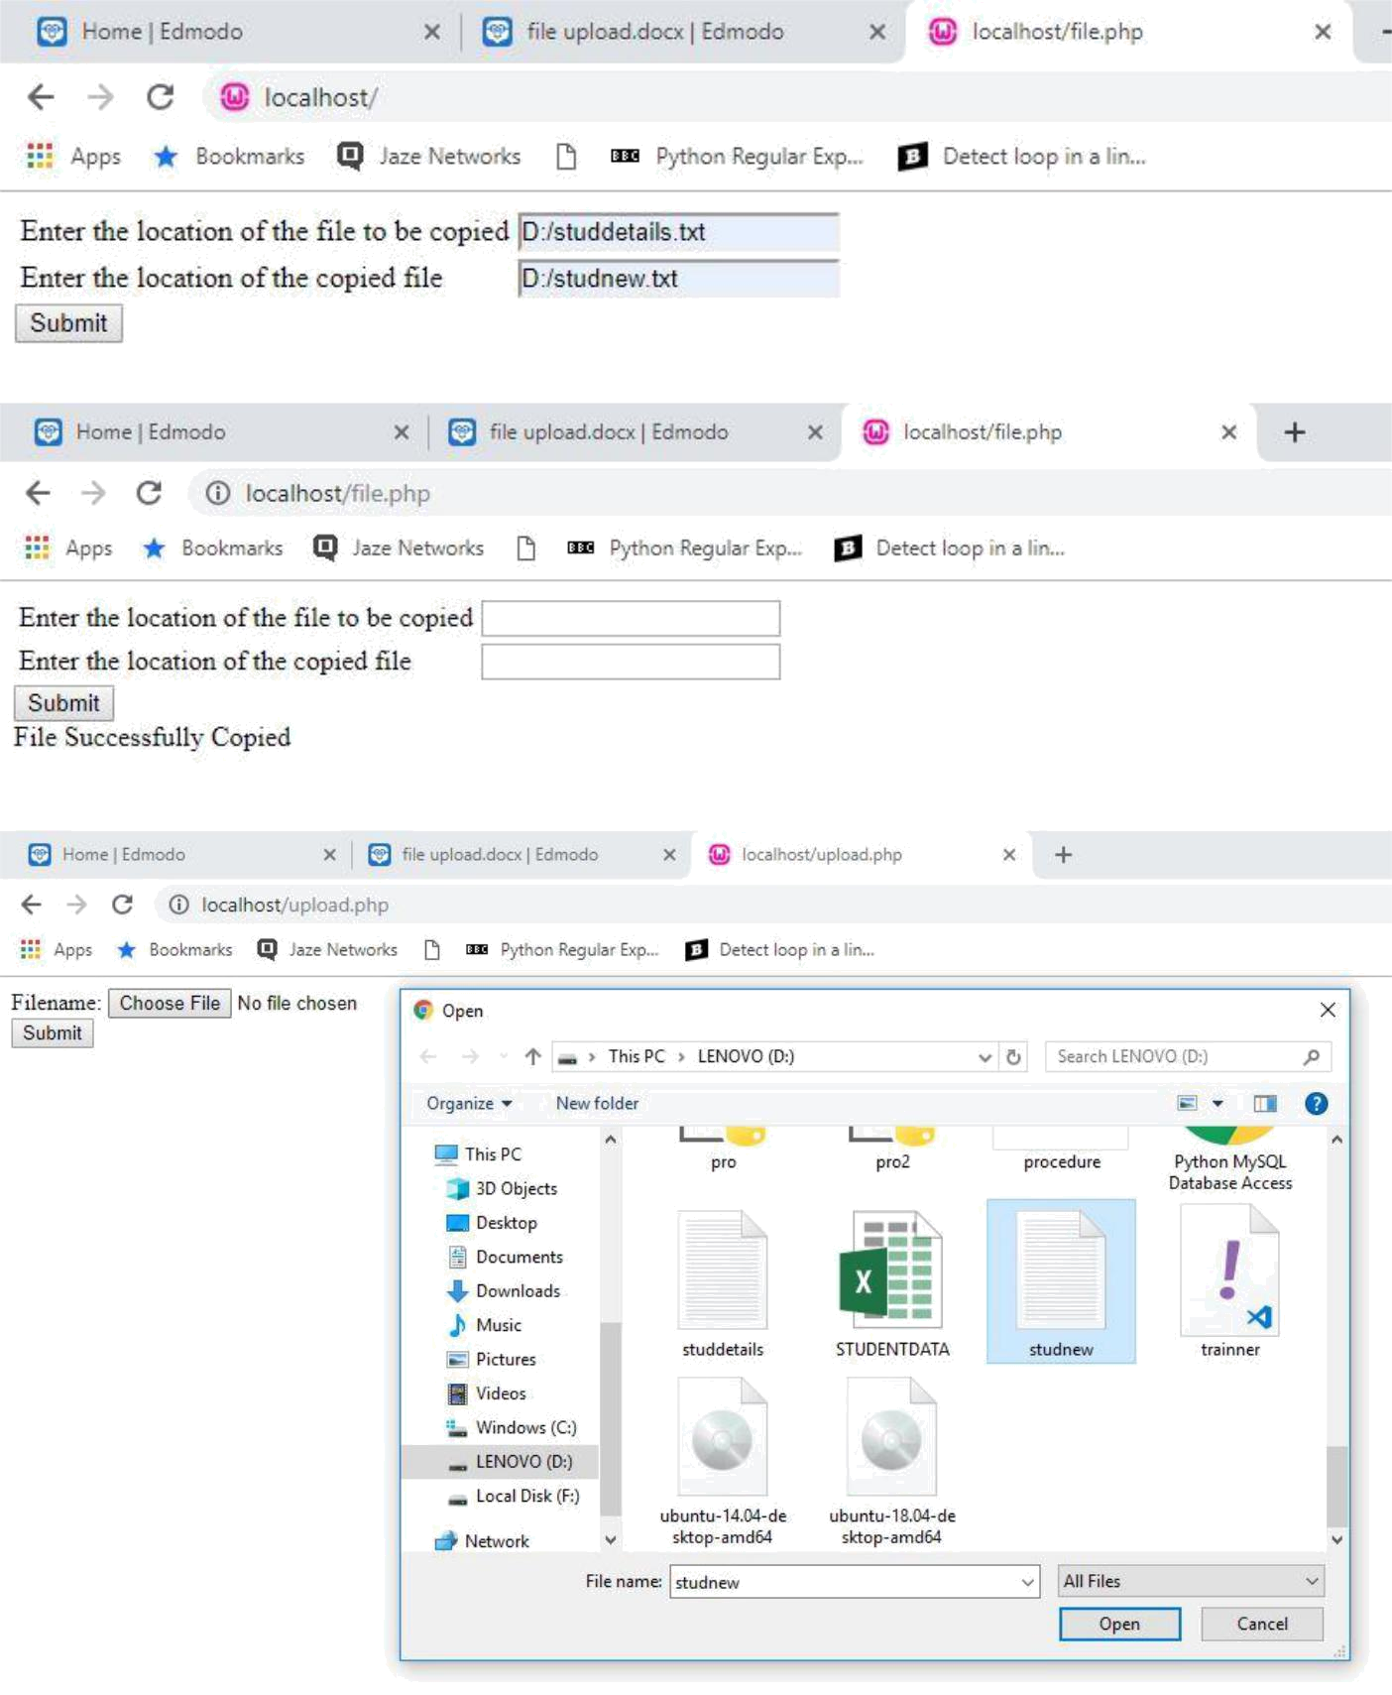

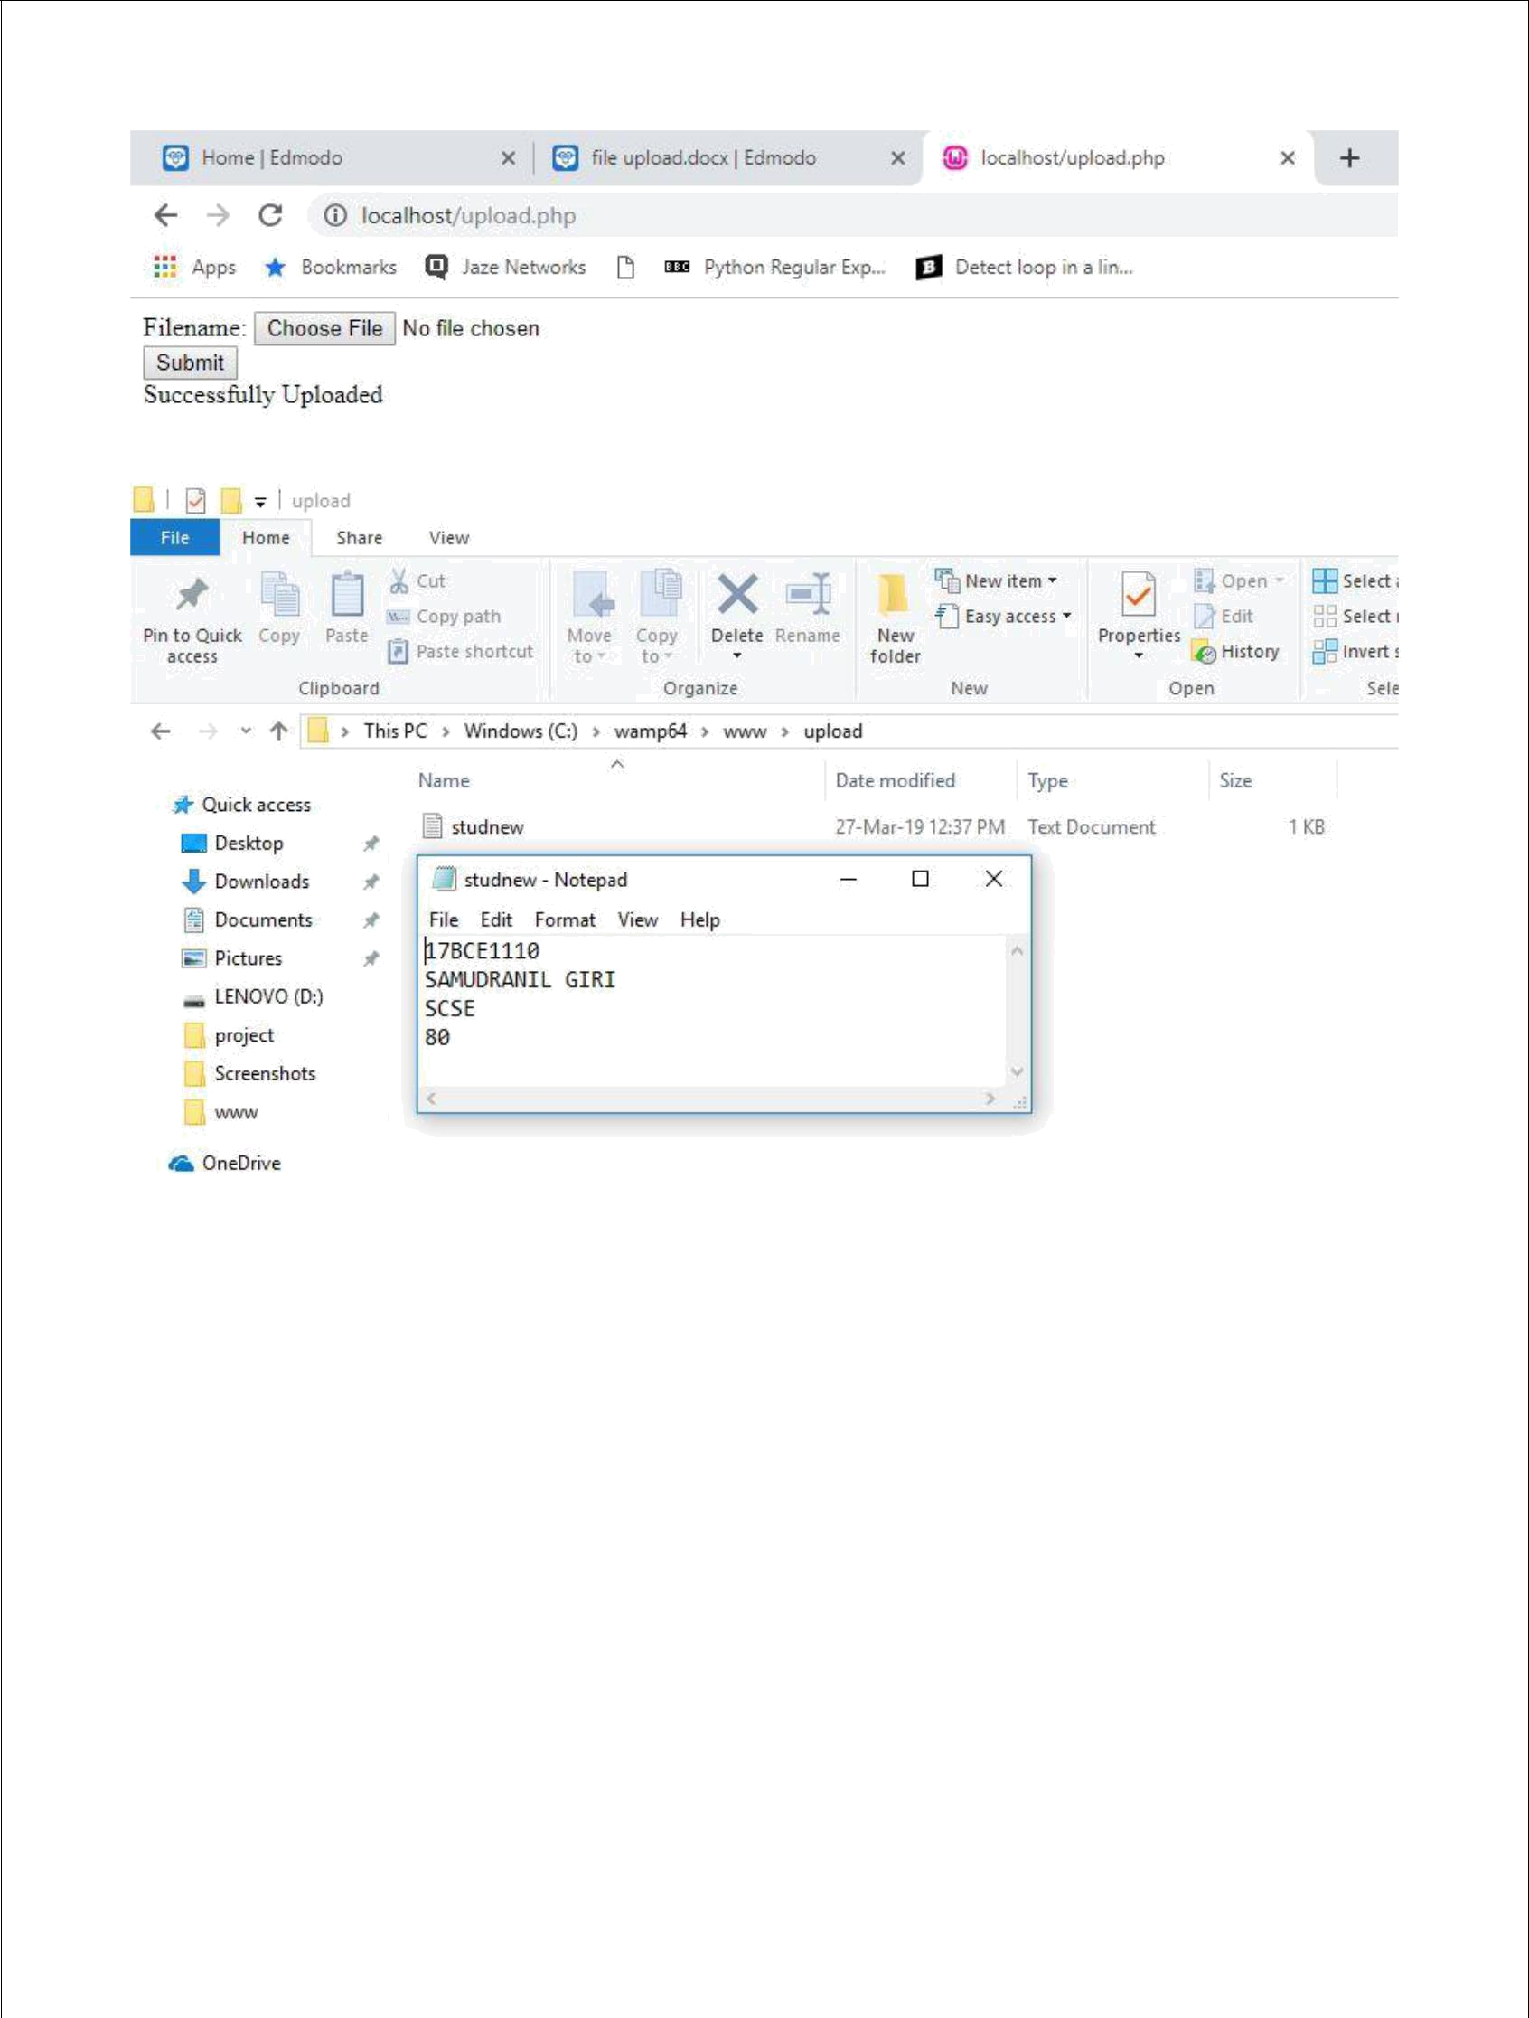

**Ex No 2:**

Create a XML file and DTD for student details:

Student – root node

Register number – attribute of root node (must be unique and required) Name – child node

First name and last name - child of name(last name may have 0 occurance)

Age – child node graduate – child node (ug/pg)

program – child node(btech/Mtech)

degree – attribute of program (enumerated values including CS/ECE/IT) and required

Validate the XML file against DTD using online XML validator.

Check both as external and internal DTD.

.dtd file:

<!DOCTYPE student [

<!ELEMENT student (name,age,graduate,program)> <!ELEMENT name (first_name,last_name?)> <!ELEMENT first_name (#PCDATA)> <!ELEMENT last_name (#PCDATA)> <!ELEMENT age (#PCDATA)> <!ELEMENT graduate (#PCDATA)>

<!ELEMENT program (#PCDATA)>

<!ATTLIST student reg_no CDATA #REQUIRED> <!ATTLIST program degree (CS|ECE|IT) "CS"> ]>

.xml file

<student reg_no="1000">

<name>

<first_name> Nikhil </first_name>

<last_name> Neogy </last_name>

</name>

<age> 19 </age>

<graduate> UG </graduate>

<program degree="CS"> B.Tech </program> </student>

Output:

Internal

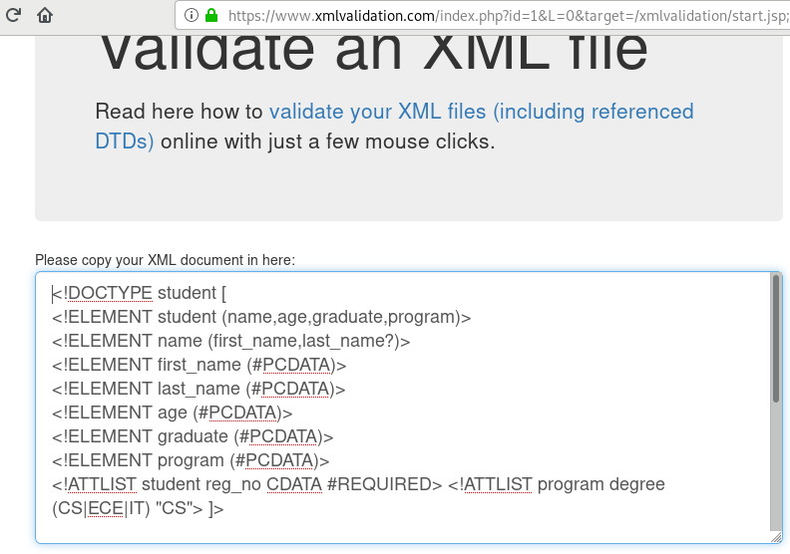

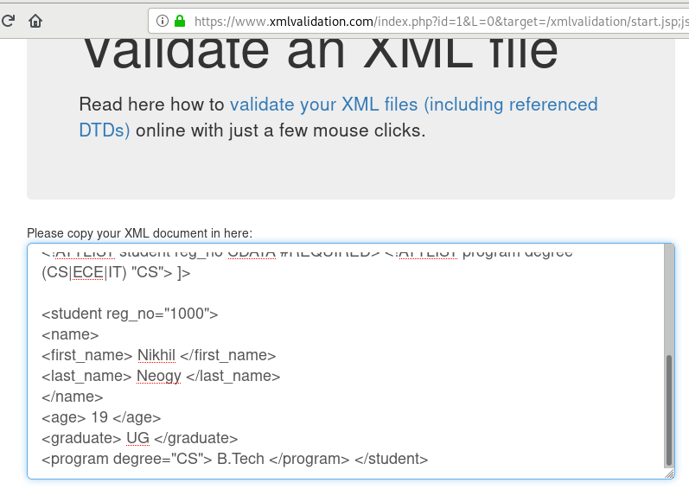

External

